The Heaton Chapel Active Neighbourhood Trial will be taking place in your area this autumn, commencing in early September 2021, and running until the end of November 2021.
An Active Neighbourhood aims to enable residents to make short trips on foot, by cycle or by public transport, instead of jumping in their car. Active Neighbourhoods also seek to make residential roads a safer place for all users, particularly those living there, by removing rat runs and slowing trac down.
Types of measures
We’re using Road Closures (Modal Filters)
We’ll be closing several streets in Heaton Chapel to through trac. This will limit through journeys long a street by certain modes of transport, in this case motor vehicles. Such road closures are known as modal filters. Modal filters will still allow pedestrians, cyclists, wheelchair users and mobility scooters to pass, but motor vehicles will not be able to travel through them.
Modal filters will consist of raised flower beds (planters) placed across carriageways and some sections of wider footways to physically prevent any vehicle wider than 1.5m passing through them. 1.5m is the minimum amount of space required as per published government guidelines (LTN 1/20) to permit wheelchairs, double buggies, cyclists and mobility aids such as mobility scooters to pass through. Signage on each modal filter will indicate that all motor vehicles, including motorcycles, cannot pass, and it will be illegal for them to do so under road trac regulations.
This leaflet will explain the trial measures, show you where they’re located, and explain the reason we’re installing each measure. It will also let you know where we’ve made changes to the trial scheme based on feedback we’ve received, and answer some of the most commonly asked questions about the Active Neighbourhood trial. The map inside shows the locations of each of the measures which will be put in place as part of the trial. These are all explained further overleaf.

Pocket Park
Pedestrian Improvements
We’ll be creating a pop-up pocket park in Heaton Chapel. A pocket park is a small communal outdoor space that’s placed in an area not normally used for a park, such as a car parking space or a section of roadway. Pocket parks consist of places to sit and unwind, such as benches and picnic tables and different types of plants and vegetation, creating a pleasant outdoor space – just like a park, but on a smaller scale.
Pocket Parks can also include play equipment. Pocket parks are also about giving outdoor space back to people, in areas where much of it is dominated by motor vehicles.
Improvements for Pedestrians and Footway Users
We’ll be making some improvements for pedestrians, wheelchair users, mobility scooters and other users of the footway, to make it easier to get around. This includes installing a new temporary signalised pedestrian crossing and modifying some access barriers and chicanes to allow wheelchair users to pass.

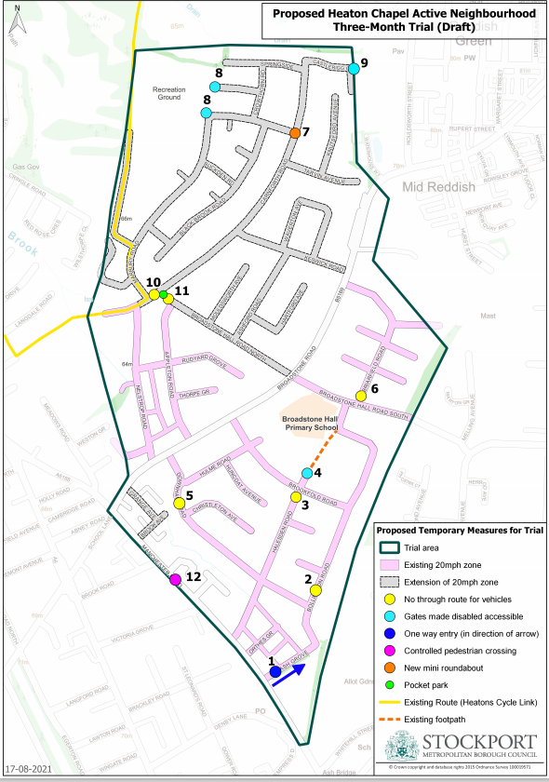
Location of measures

1 Ash Grove
We’re making Ash Grove one-way for the duration of the trial, from Manchester Road to Bollington Road, meaning Ash Grove will become ‘entry only’ at the Manchester Road junction. This will mean that motor traffic will not be able to exit onto Manchester Road from Ash Grove but will be able to enter Ash Grove when travelling either direction on Manchester Road. We’re doing this to improve safety as the carriageway is narrow on Ash Grove and it’s difficult for two motor vehicles to pass each other. Making it one-way will also help remove the rat running that takes place at this location.
2 Bollington Road
We’ll be placing a modal filter towards the southern end of Bollington Road near its junction with Downham Road. It will be located on the existing speed hump between numbers 25 and 26. The modal filter is being placed here to remove the rat run between Broadstone Hall Road South and Manchester Road. This will mean that when driving a motor vehicle, residents living on Bollington Road north of the modal filter will access their houses from Broadstone Road, while residents south of the filter will access their homes from Manchester Road.
We’ve listened to your feedback: Nearby residents asked us to look at placing the modal filter on or beside the speed bump, due to concerns about noise generated by motor vehicles travelling over the bump.
3 Halesden Road
We’ll be placing a modal filter at the northern end of Halesden Road, just behind the give way line on its junction with Brookfold Road. This will mean most residents of Halesden Road, when driving a motor vehicle, will take their access from Manchester Road.
We’ve listened to your feedback: Nearby residents asked us to move the modal filter to this location at the top of the junction, as they were worried about school parking on Brookfold Road using the top of Halesden Road.
4 Path west of the Common
We’ll be making some changes to the access control barriers (chicanes) at the northern end and the southern end of the path that runs between the Common and Broadstone Hall Primary School from Bollington Road to Halesden Road. The current metal barriers on this path are too narrow to safely permit some wheelchairs, double buggies and other mobility aids from passing through them, and therefore are discriminatory towards some road users. We’ll be removing the current barriers and replacing them with a new wider chicane at the Halesden Road end which will provide more space for wheelchairs and buggies to pass.
5 Downham Road
We’ll be placing a modal filter next to the existing speed hump on Downham Road, just to the west of its junction with Christleton Road. This will remove the through route from Broadstone Road and Manchester Road via Downham Road, cutting the rat run, and will also prevent any vehicles which previously used Bollington Road or Halesden Road as a rat run switching to using Downham Road instead when these roads are also closed to through traffic. This will mean when driving a motor vehicle some Downham Road residents will access their properties from Broadstone Road, and some Downham Road and all Christleton Road residents will access their properties from Manchester Road via Halesden Road or Ash Grove.
We’ve listened to your feedback: Some residents suggested we move the modal filter to the eastern side of Downham Road’s junction with Christleton Avenue, so that residents of Christleton Avenue could take their access from Boradstone Road when driving. Unfortunately, moving the modal filter to the eastern side of the junction would create a long cul-de-sac on Downham Road that would not leave sufficient space at its western end to turn a refuse vehicle around. Due to health and safety guidelines, a cul-de-sac without a turning head can’t be more than 65m and placing the modal filter on the eastern side of the Christleton Road junction would create a cul-de-sac of over 200m with no turning area for refuse vehicles. This is why we’re placing the modal filter to the west of the junction, as refuse vehicles or delivery vehicles serving the eastern section of Downham Rd can continue to turn around at the northern end of Christleton Avenue.
6 Briarfield Road
Briarfield Road will cease being a through route for vehicles. This will eliminate rat running from Broadstone Road to Broadstone Hall Road South, and create a quiet cul-de-sac. We’ll be placing a modal filter at the southern end of Briarfield Road, at its junction with Broadstone Hall Road South. Pedestrians, mobility scooters, wheelchair users and cyclists will still be able to travel through this junction to/from Briarfield Road, but motor vehicles will not.
We’ve listened to your feedback: Following suggestions from residents, we’re placing the modal filter at the bottom of Briarfield Road, and not half way up Briarfield Road as previously suggested. This will mean the road is not cut in two, and residents on Briarfield Road, Bowness Avenue, Arnside Avenue, Burnside Avene, Cartmel Avenue and Grassmere Avenue will access their homes from Broadstone Road when driving. Placing the modal filter at the junction with Broadstone Hall Road South will also help discourage school parking on Briarfield Road.
7 Marbury Road
In order to slow trac down and make motor vehicles drive more carefully, we’ll be installing a mini-roundabout at the junction of Marbury Road and Carnforth Road. This will help slow down drivers who speed up when travelling along Carnforth Road. The mini-roundabout will be supported by speed cushions installed either side of it. Slowing trac on Carnforth Road will make it safer to turn in and out of Marbury Road.
8 Greenthorn lane and Holcombe Walk playground
In order to allow access for wheelchair users, prams and bicycles, we’ll be modifying two gates into the park and playground at the end of Greenthorne Avenue and adjacent to Holcombe Walk. The current ‘swing’ or ‘kissing’ gates to not allow anyone except a single able-bodied pedestrian to pass, which excludes other users such as people with wheelchairs and mobility scooters, and parents with prams. We’ll be removing part of the gate to improve access for all users, and this will be done at the gate closest to Marbury Road, and the gate closest to Greenthorne Avenue.
9 Path from Castlerigg Close to Houldsworth Park
We’ll be removing the narrow metal chicane barrier on the pathway between Castlerigg Close and Houldsworth Park. This barrier is currently too narrow to allow a wheelchair or mobility scooter user to pass through.
10 Carnforth Road
Due to numerous complaints about speeding, we’ll be putting automatic speed indicator signs on the northern end of Carnforth Road, just south of the mini roundabout at the Marbury Road junction. These signs will register motorists’ speeds and inform them to slow down if they are exceeding the 20mph limit. A modal filter will be installed at the southern end of Carnforth Road, near where it joins Nelstop Road, just south of its junction with Broadstone Hall Road North, and just north of its junction with the southern end of Marbury Road. This will stop through journeys from Carnforth Road to Nelstrop Road, and from the southern end of Carnforth Road directly to Broadstone Hall Road North. Residents on Carnforth Road and side roads o it will take their access via Keswick Road when travelling by motor vehicle to/from Broadstone Road. A secondary route via Marbury Road will remain open.
11 Broadstone Hall Road North
We’ll be installing a pocket park at the western end of Broadstone Hall Road North, between its junctions with Carnforth Road and Appleton Road. This will mean that there will be no through route from Broadstone Hall Road North to Carnforth Road and vice versa at this location. A 1.5m wide cycle lane will be installed to allow non-motorised road users to pass through. The pocket park will be placed on the carriageway adjacent to the green area and will provide an outdoor space for the community to meet, relax and enjoy the outdoors. There will be bench seating provided, along with various shrubs and plants, a picnic table, and a ping pong table. This area will be protected from trac on Carnforth and North Broadstone Hall Roads by barriers.
12 Manchester Road Pedestrian Crossing
We’ll be installing a new temporary pedestrian crossing for the duration of the trial on Manchester Road, near the junction with Brooklands Close. This will make it easier for pedestrians walking towards the shops and services on the lower part of School Lane and the southern side of Manchester Road, as well as aiding on-foot journeys towards Wellington Road North and Heaton Chapel Railway Station.
Good to know!
Emergency Vehicles will still be able to access all residences in the Active Neighbourhood area. We’ve consulted with Greater Manchester Police and showed them the trial scheme and placement of the modal filters. They’ve told us they don’t have an issue with the scheme design and will share our plans amongst their partners in the Emergency Services so they know about which roads won’t be through routes for the duration of the trial. We have spoken to the operators of the Council’s refuse vehicles, and rounds will be altered to take account of the modal filter points. Bin days will remain as they are now.
Good to know!
No resident will be unable to access their house when driving a car. All residents will continue to have access to their driveways. Some residents may have to take a slightly different route to the one they would normally take in order to get to/from their home when using a motor vehicle, and this may increase journey times slightly.
Good to know!
Stockport Council’s Active Neighbourhoods programme is supported by the sustainable travel ambitions of the Greater Manchester Combined Authority (GMCA), Transport for Greater Manchester (TfGM), and the UK Government’s Department for Transport. The Heaton Chapel Active Neighbourhood Trial has been funded by the GMCA and the DfT’s Active Travel programme.

Talk to us!
Once the trial Active Neighbourhood scheme has been in place for one month, we’ll be holding a drop-in feedback session for residents. It will be held at Broadstone Hall School on 5th October 2021 from 18:00-20:00 (subject to any Covid-19 restrictions at that time). This will be a free event for residents to talk to Stockport Council about the scheme, feedback their experiences of the trial so far, and let us know of any issues and successes.
There will also be an online feedback workshop on 6th October 2021 at 19:00 for any residents who are unable to attend the in-person session on 5th October. You can sign up for the online workshop by visiting:
Tinyurl.com/activeheatons
https://www.stockport.gov.uk/current-proposals/active-neighbourhoods
And remember…
This is a three-month trial. At the end of the trial period at the end of November, we will remove the planters and the modal filters and reopen the roads to through traffic. We will then engage with residents to gain feedback on the trial, and see what people felt worked and what didn’t. We’ll then use this information to look at potentially installing some permanent trac calming and modal filtering measures in in 2022. We will consult residents in advance on any future permanent scheme, which will need approval from the Councillors at Heatons and Reddish Area Committee before going ahead.

Any issues with the trial once it has been installed please call 0161 2176043 or email activeheatons@stockport.gov.uk. For emergency, out of hours enquiries, please call 0161 474 5555.

