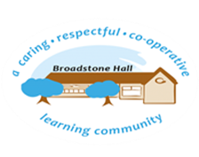

subject overview – Personal, Health, social and economic education

It is through our whole school approach to PHSE, that we believe we provide our pupils with the tools to become healthy, independent and responsible members of society.

We want our children to be able to understand and reflect on how they are developing personally and socially. In turn, this will give them the confidence to tackle moral, mental, physical, social and cultural issues that are part of growing up.

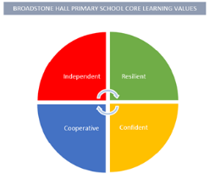

Inclusive Practice

PHSE is taught in a way which lends itself to pair, group and whole class discussions (often through circle time). Giving everyone the opportunity to share their own opinions, life experiences and ideas.

Core Threads

1. To be able to recognise, build and maintain healthy relationships
2. To use emotional literacy
3. To be able to make their own decisions to keep themselves safe and healthy.

BHPS Learning Values

Resilience – The opportunity to discuss (sometimes tricky) topics, emotions and decision making.

Independence –. The opportunity to talk about their own feelings, ideas and life experiences.

Confidence – The opportunity to receive a safe and valued environment where the children feel they can share ideas. (linked to circle time rules)

Cooperation – The opportunity to listen to other people’s viewpoints and discuss them.

Links to Reading

* Scenarios
* Question cards
* Facts/statistics
* Stories (with PHSE links)
* Newspaper articles
* Personal viewpoints

Long Term Learning

Use of relevant videos and resources to help the pupils understand ideas and concepts through the ‘eyes of children’ of a similar age. Through the videos and resources our pupils are given the opportunity to make decisions, where the consequences are then discussed.

Sequence of Learning

In EYFS, children are supported to manage emotions, develop a positive sense of self, have confidence in their own abilities and build healthy relationships. This is then built on through Years 1-3 by having a consistent and developmental curriculum focussing on: keeping safe, staying healthy, relationships, being responsible, feelings and emotions, computer safety, our world, fire safety and hazard watch. Then, built on further through Years 4-6 with the introduction of growing and changing, a working world and a world without judgement.