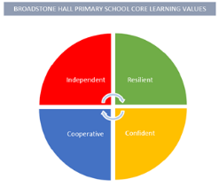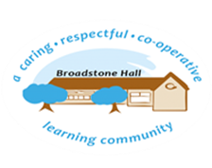

In Religious Education, we aim to engage pupils in systematic enquiry into significant human questions which religion and worldviews address, so that they can develop the understanding and skills needed to appreciate and appraise varied responses to these questions, as well as develop responses of their own. At Broadstone Hall, we want children to have the skills and knowledge to explore the big questions about life, find out what people believe and what difference this makes to how they live, make sense of religious and non-religious views and reflect on their own ideas and ways of living.

subject overview -Religious Education

Core Threads

1. Know about and understand a range of religious and non-religious worldviews.
2. Express ideas and insights about the nature, significance and impact of religious and non-religious worldviews.
3. Develop the skills needed to engage with religious and non-religious world views.

Inclusive Practice

The practical nature of the RE curriculum lends itself to an equitable teaching and learning experience; where all children have a purposeful role in the systematic enquiry into significant key questions. Children will have the opportunity to investigate, enquire, explain and respond to the questions posed, enabling all to succeed.

Links to Reading

* Religious Texts
* Recounts
* Balanced argument and discussion texts
* Websites
* Religious Stories / Fables
* Subject Specific Vocabulary
* Information Texts

BHPS Learning Values

Resilience – Opportunities to enquire, investigate, describe and express ideas and beliefs in response to key questions.

Independence – Opportunities to develop and express their personal reflections and critical responses to key questions.

Confidence – Opportunities to articulate their beliefs, personal reflections and explain other people’s values.

Cooperation – Opportunities to appreciate and appraise the nature, significance and impact of different ways of life and respect the rights of others to differ.

Long Term Learning

Previous key concepts and vocabulary recapped and built upon and links with prior learning made and developed. Use of Cooperative Learning Strategies to discuss, embed and understand key concepts and vocabulary.

Sequence of Learning

In EYFS, children will encounter Christians and people of other faiths, as part of their growing sense of self, their own community and their place within it. In Key Stage One, this is built on as children are taught about who is and what do Christians, Muslims and Jews believe. In Key Stage 2, this knowledge and understanding is further developed and explored in greater depth. Non-religious world views are also explored in key stage 2, such as humanism and atheism.