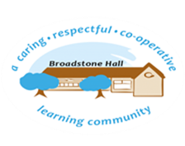

In Science we want our children to develop curiosity about and a deep understanding of the world around them, ask questions and seek to find answers through different investigation processes and the acquisition of precise scientific vocabulary. At Broadstone Hall, we want children to have the skills and knowledge to think scientifically and understand the importance of science in everyday life and its impact on our lives, now and in the future.

subject overview - science

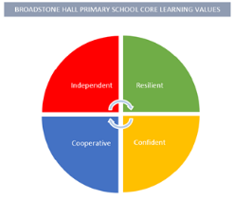

Core Threads

1. Working scientifically (processes, methods, prediction, enquiry)
2. Thinking and talking scientifically (reasoning, vocabulary)
3. Impact of science on our lives and for our future

Inclusive Practice

The practical nature of the science curriculum lends itself to an equitable teaching and learning experience; where all children can have a purposeful role in carrying out scientific enquiry activities. Children will have the opportunity to draw, model, build and talk about their learning in a variety of ways, enabling all to succeed.

Links to Reading

* Scientific Vocabulary
* Reports
* Biography of scientists

eg Darwin

* Recounts
* Instructional Texts
* Research Articles
* Balanced argument and discussion texts
* Explanation Texts

Long Term Learning

Use of Knowledge Mats at the start and throughout a unit of work. Use of Cooperative Learning Strategies to discuss, embed and understand key concepts and scientific vocabulary.

BHPS Learning Values

Resilience – Opportunities to plan, carry out, review and evaluate scientific experiments.

Independence – Opportunities to research and enquire answering their own questions about the world around them.

Confidence – Opportunities to build on prior knowledge, predict and articulate scientific concepts clearly and precisely.

Cooperation – Opportunities to work collaboratively with peers in experiments and investigations.

Sequence of Learning

In EYFS, children are encouraged to observe the world around them, ask questions and talk about what is similar and what is different. In Key Stage One, this is built on through planned units of work that are timed to fit in with the Natural World and in the context of other areas of learning. In Key Stage Two, further development of children’s understanding expands their understanding of the world around them, the universe beyond and how it is thought about scientifically.