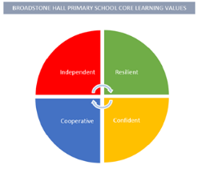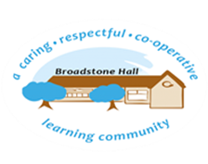

At BHPS school we want children to be confident and safe users of technology. Technology is everywhere and will play a pivotal part in the future success of our children as they strive to make a positive contribution to society. Therefore, we want to model and educate our children on how to use technology positively, responsibly and safely. We want our pupils to be creators not consumers and benefit from our broad curriculum encompassing Digital Literacy, Online Safety, Computational Thinking and Hardware.  
We recognise that technology can allow children to share their learning in creative ways. We also understand the exciting opportunities technology can provide for our children. Our practical approach to curriculum delivery offers the opportunity for children to apply their knowledge creatively which will in turn help them to become skilful computer scientists.

subject overview - Computing

BHPS Learning Values

Resilience – Opportunities to use technology as a tool to solve logical problems through trial and error

Independence – Opportunities to research, enquire, experiment, create and develop using technology to be creators not consumers

Confidence – Opportunities to apply their knowledge creatively which will in turn help them to become skillful computer scientists

Cooperation – Opportunities to work collaboratively with users locally, nationally and across the globe to showcase their outcomes and creativity

Links to Reading

* Computing Vocabulary
* Research Articles/Websites
* Coding Texts
* Instructional Texts
* Explanation Texts
* Algorithms
* Web sites

Inclusive Practice

Computing is a practical and hands-on subject, where children learn through experience, research and investigation. Multiple methods of representation in computing; icons, pictoral and text mean accessibililty is built in to learning.

Core Threads

1. Online safety - using technology positively, responsaibily and safely
2. To be responsible, competent, confident and creative users of information and communication technology
3. To understand the impact of technology on our everyday lives and future opportunities it presents

Long Term Learning

Skillls and knowledge are developed in EYFS and all learning builds on previous learning providing both support and challenge. Core threads, such as e-safety are taught every year to ensure learning is revisited and built on, deepening understanding.

Sequence of Learning

At BHPS we aim for all children to master computing and make use of computing in their everyday lines, without being completely reliant on technology. We follow a structured approach to delivery that ensures progression of skills across the school and provides opportunities for all learners to have opportunities and experiences in all aspects of the computing curriculum. Our computing curriculum will contribute to children’s personal development in creativity, independence, calaberation and resilience. Children will cover the following concepts logic, algorithms, decomposition, patterns, abstraction and evaluation through tinkering, creating, debugging, persevering and collaborating.