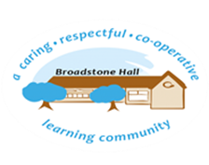

In History, we aim to provide children with learning opportunities to develop their understanding of the past in Britain and the wider world. Through a carefully planned, broad and balanced curriculum, children can develop a secure understanding of chronology, the significance of different historical periods, key figures and how this impacts our lives today. By finding out about how and why the world, our country, culture and local community have developed over time, children understand how the past influences the present and how the past has been interpreted by different people at different times. What they learn through their history lessons can influence their current decisions about personal choices, attitudes and values. Through the study of historical evidence and sources and by exploring their local area, pupils will develop a deep understanding. Our intention is that children learn both *about* history and *from* history.

subject overview - History

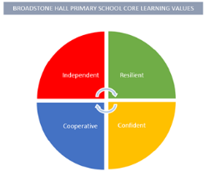

Core Threads

1. Chronology (Life in Britain & the wider world linked and in order)
2. Historical concepts (Cause & consequence, similarities & differences)
3. Enquiry (Asking perceptive & valid questions, analysing artefacts & sources)

BHPS Learning Values

Resilience – Opportunities to look at and evaluate a range of historical sources and justify their importance.

Independence – Opportunities to research and enquire answering their own questions about the past.

Confidence – Opportunities to build on prior knowledge and articulate historical concepts and ideas, clearly and precisely.

Cooperation – Opportunities to work collaboratively with peers when looking at objects, artefacts and other sources.

Links to Reading

* Historical vocabulary
* Reports and recounts of events e.g. letters and diaries
* Historical texts
* Images and artefacts
* Writing from a variety of cultures and traditions
* Research articles
* Explanation texts

Inclusive Practice

The hands-on nature of the history curriculum lends itself to an equitable teaching and learning experience; where all children can have a purposeful role in carrying out enquiry activities. Children will have the opportunity to explore how we can learn from the past by using pictures, objects and written sources. They can show their ideas by drawing, talking and writing about their learning in a variety of ways, enabling all to succeed.

Sequence of Learning

In EYFS, children are encouraged to look at their own lives and compare how it is similar/different to lives of those in the past. They can look at objects and make comments /ask questions about its age and appearance. They can draw/tell you about the past using common words and phrases linked to the passing of time. In KS1, children are developing their ability to put people and events on a timeline. They can find out similarities/differences by asking questions and linking previous learning. They can share how we find out about things from the past and how we might analyse artefacts to help us learn more. Children can also explain the importance of important people and events. In KS2, children can understand the changes across and within Britain’s past and link this to the wider world. Children can also understand that the past can be represented and interpreted in many ways. Children are also able to devise their own historically valid questions and use this to help them select reliable and relevant sources of information.

Long Term Learning

Use of Knowledge Mats at the start and throughout a unit of work. Use of Cooperative Learning Strategies to discuss, embed and understand key concepts and scientific vocabulary.