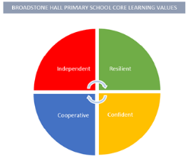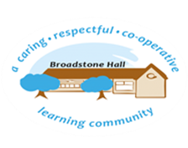

subject overview – art in eyfs (creating with materials & being imaginative)

Intent

Our children will be encouraged to express their feelings, emotions and experiences through different medium. Using techniques modelled to them, children will develop their motor skills and confidence to talk about their process.

Development Matters Statements and Early Learning Goals

**Nursery (3-4 year)**

* Explore different materials in order to develop their ideas about how to use them and what to make
* Join different materials and explore different textures
* Use drawings to represent ideas and create closed shapes with continuous lines
* Explore colour and colour mixing

**Reception**

* Explore, use and refine a variety of artistic effects to express their ideas and feelings
* Create collaboratively to share ideas, resources and skills

**ELG**

* Safely use and explore a variety of materials, tools and techniques, experimenting with colour, design, texture, form and function
* Share their creations explaining the process they have used

What This Looks Like In An EYFS Environment

In Nursery children have opportunities to paint, draw, sculpt and create collages. They have continuous access to a dough area, creative area with paints and drawing opportunities in all Continuous Provision areas. Children explore these areas alongside quality adult interaction and modelling. Painting resources include sponges, stamps, blocks and thick paint brushes. Drawing resources include chunky pens, wax eggs, felt tips and chalk. Sculpting resources include construction resources and play doh. Collage resources include loose parts and glue for joining.

In Reception children also have opportunities to paint, draw, sculpt and create collages. They have continuous access to a dough area, creative area with paints and drawing opportunities in all Continuous Provision areas. Children explore these areas alongside quality adult interaction and modelling. Painting resources include different sized brushes, palletes for colour mixing and books and artists for inspiration. Drawing resources include assorted sized felt tips, charcoal, different sized pencils and books for inspiration. Sculpting resources include construction resources and equipment in the dough area to encourage experimentation with design and form. Collage resources include a wide range of materials. Junk modelling is also available.