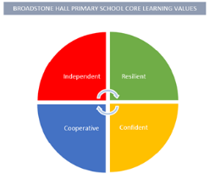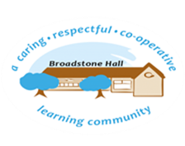

subject overview – DT in eyfs (creating with materials & Being imaginative)

Intent

Our children will be encouraged to create for a purpose, independently using a variety of techniques and resources.

Relevant Development Matters Statements and Early Learning Goals

**Nursery (3-4 year)**

* Explore different materials in order to develop their ideas about how to use them and what to make
* Develop their own ideas and decide which materials to use to express them
* Join different materials and explore different textures

**Reception**

* Explore, use and refine a variety of artistic effects to express their ideas and feelings
* Build on previous learning and refine ideas to represent them
* Create collaboratively to share ideas, resources and skills

**ELG**

* Safely use and explore a variety of materials, tools and techniques, experimenting with colour, design, texture, form and function
* Share their creations explaining the process they have used
* Make use of props and materials when role playing characters

What This Looks Like In An EYFS Environment

In Nursery children have a wide variety of opportunities to develop their imagination and creativity. Through selecting their own resources they are encouraged to represent their thoughts and ideas in their play. This is facilitated through continuous provision both indoors and outdoors. Examples of this might be materials to build dens, large blocks or various construction toys.

In Reception children are encouraged to create for a purpose using their imagination. Through adult led modelling and quality interaction children are taught various techniques to develop their Design and Technology skills. This might be using split pins and a hole punch to create a book, building a pirate ship using crates or making a till to take into the home corner. Children are then encouraged to talk about how they achieved their creation and what its purpose is.