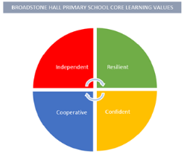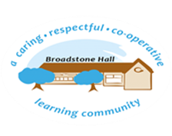

subject overview – Geography in eyfs (the natural world & People, cultures and communities)

Intent

Through stories and images, our children will begin to understand a comparison of life in other countries to their own. They will gain extensive experience and knowledge of their local area through weekly hands on, practical opportunities. Vocabulary will be modelled and enhanced through these experiences.

Relevant Development Matters Statements and Early Learning Goals

**Nursery (3-4 year)**

* Talk about the differences between contrasting countries drawing on their own experiences
* Begin to understand the need to respect and care for the natural environment

**Reception**

* Draw information from a simple map
* Recognise similarities and differences between life in this country and other countries
* Explore different environments to where they live

**ELG**

* Know some similarities and differences between the natural world around them and contrasting environments, drawing on their experiences and what has been read in class
* Describe their immediate environment using knowledge from observation, discussion, stories, non-fiction texts and maps

What This Looks Like In An EYFS Environment

In Nursery children use holiday photos to promote discussion about contrasting areas or countries. Children are also taught to respect their immediate environment through quality adult interaction and play.

In Reception children have access to books and photos that relate to different environments, drawing on their own experiences. New vocabulary that is promoted on the Weekly Wanders is regularly enhanced through opportunities in the learning environment.

Key Experiences

Nursery

* Photos of family holidays
* Visits to the Wild Area to gain an understanding of their immediate environment

Reception

* Weekly Wanders around local area to develop understanding of where we live
* Working ‘Map Wall’ for exposure to a simple map linked to local area