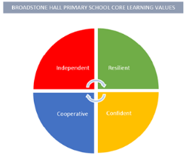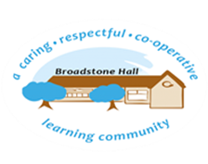

subject overview – history in eyfs (past and present)

Intent

Our children will develop an understanding of the past through discussions surrounding family photos, celebrations and key historical events. They will also develop a wide range of vocabulary that stems from their hands on experiences of the history of their local environment.

Relevant Development Matters Statements and Early Learning Goals

**Nursery (3-4 year)**

* Talk about their families and key life experiences
* Show interest in different occupations

**Reception**

* Talk about images of familiar situations in the past
* Compare and contrast characters from stories including figures from the past

**ELG**

* Talk about the lives of people around them and their roles in society
* Know some similarities and differences between things in the past and now, drawing on their experiences and what has been read in class
* Understand the past through settings, characters and events encountered in books read in class and story telling

What This Looks Like In An EYFS Environment

In Nursery children use photos from home to talk about their experiences. Visits from ‘People Who Help Us’ give the children exposure to other occupations.

In Reception children have access to books and photos that highlight past events in their lives and those of their families. Fairy tales are used to highlight the past through settings. Key historical events throughout the year such as Bonfire Night and Remembrance Day to highlight key historical figures. Children’s family photos are displayed around the classroom to promote regular discussions.

Key Experiences

Nursery

* Photos of family members
* Photos of themselves when they were younger
* Photos of family members when they were younger for comparison
* Dentist, Doctor, Firefighters, Police and Paramedic visits

Reception

* Photos of family members and key life events
* Photos of old houses, parents and grandparents when they were younger
* Dentist, Doctor, Firefighters, Police and Paramedic visits
* Baby visits and visits from grandparents to discuss life then and now
* Weekly Wanders to the old Mills and churches in Reddish