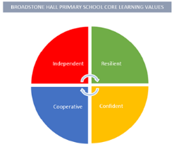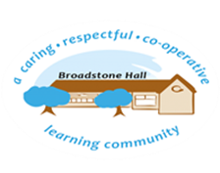

subject overview – music in eyfs (being imaginative)

Intent

Our aim is to introduce children to the world of music and all it has to offer. Through exposure to songs, melodies, rhythms and beats our children will become more confident performers, singers and dancers.

Relevant Development Matters Statements and Early Learning Goals

**Nursery (3-4 year)**

* Remember and sing entire songs and respond using their thoughts and feelings
* Sing the pitch of a tone sung by another person and sing familiar songs
* Create their own songs or improvise a song they know and play instruments with increasing control

**Reception**

* Listen, move and talk about music
* Sing in a group or on their own following the melody
* Engage in music making and dance

**ELG**

* Sing a range of well-known nursery rhymes and songs
* Perform songs, rhymes, poems and stories and try to move in time with music

What This Looks Like In An EYFS Environment

In Nursery their initial exposure to different sounds, instruments and nursery rhymes is taught through Phase 1 phonics. Children also take part in a nativity show where they are all actively encouraged to learn and sing a variety of new songs. Nursery rhymes are also sung as part of regular daily routines. Instruments are also available in the continuous provision and children are actively encouraged to explore rhythm and make up their own songs.

In Reception children follow the Charanga scheme. Children are taught to follow beats, clap rhythms and sing along to different melodies. Instruments and a stage are available in the outdoor provision where children are encouraged by adults to perform songs. Children also take part in a nativity show and emphasis is put on following the correct melodies and rhythm.