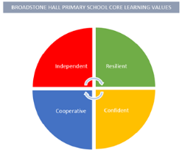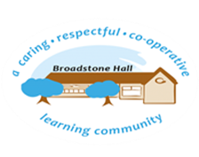

subject overview – PHSE (Personal, social & emotional development)

Intent

Through quality adult interaction and support, our children will be given skills and tools to regulate their emotions, build meaningful relationships with peers and appropriate adults and understand how their behaviour affects others.

Relevant Development Matters Statements and Early Learning Goals

**Nursery (3-4 year)**

* Help find solutions to conflicts and rivalries and follow rules without adult support, understanding why rules are important
* Develop appropriate ways of being assertive
* Talk about their feelings and how others might be feeling using words such as happy, sad or worried

**Reception**

* See themselves as a valuable individual, manage their own needs and moderate their own feelings socially and emotionally
* Build constructive and respectful relationships, express their feelings and consider the feelings and perspectives of others
* Show resilience and perseverance in the face of challenge

**ELG**

* Show an understanding of their own feelings and those of others, and begin to regulate their behaviour accordingly
* Be confident to try new activities and show independence, resilience and perseverance in the face of challenge
* Explain the reasons for rules, know right from wrong and try to behave accordingly
* Work and play co-operatively and take turns with others
* Form positive attachments to adults and friendships with peers
* Show sensitivity to their own and others needs

What This Looks Like In An EYFS Environment

All children take part in weekly ‘Circle Time’ sessions following the 1Decision programme. These sessions present children with real life scenarios to allow for opportunities to discuss appropriate responses and actions. Quality adult interaction and support means children can then apply these responses in situations relevant to them. Longer sessions of continuous provision allow children to build strong friendships and face real life dilemmas.