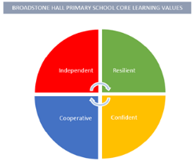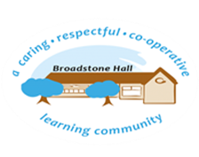

Intent

Children will develop a wide range of vocabulary that stems from their hands on experiences of their local environment. Through carefully planned, practical experiences, our children will become more aware of similarities, differences and change in the natural world.

subject overview – Science in eyfs (the natural world)

Relevant Development Matters Statements and Early Learning Goals

**Nursery (3-4 year)**

* Use senses in hands on exploration of natural materials and talk about similarities, differences and changes
* Talk about what they can see and how some things may work
* Planting, growing and life cycles

**Reception**

* Explore the natural world around them using their senses
* Talk about changes between seasons

**ELG**

* Explore the natural world around them, making observations and drawing pictures of animals and plants
* Understand some important processes and changes in the natural world around them, including the seasons and changing states of matter

Key Experiences

Nursery

* Chicks in the classroom to introduce life cycles
* Planting vegetables from seeds
* Visits to the Wild Area to observe changes
* Visits from the dentist to promote oral hygiene

Reception

* Caterpillars and Tadpoles to observe life cycles
* Planting vegetables from seeds and recognising changes
* Weekly Wanders around local area to observe seasonal changes
* Experiments including changes of state
* Visits from the dentist to promote independent healthy food choices

What This Looks Like In An EYFS Environment

In Nursery children have access to magnifying glasses, books, natural materials and an outdoor area with a wide variety of natural growth.

In Reception children have access to books, photos and hands on experiences that are regularly revisited to promote new vocabulary.

Children are also encouraged to experience a variety of experiments throughout the year to support their scientific thinking