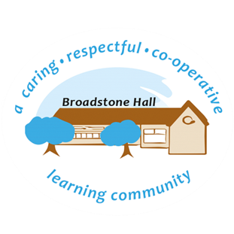
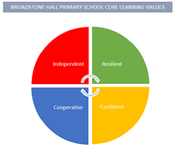
Headteacher: Mr. Martyn Taylor
Broadstone Hall Primary School
Broadstone Hall Rd South,
Heaton Chapel,
STOCKPORT,
SK4 5JD,
0161 432 1916
school.office@broadstonehall.stockport.sch.uk
www.broadstonehallschool.co.uk

Equality at Broadstone Hall

At Broadstone Hall Primary School, we welcome our duties under the Equality Act 2010 to eliminate discrimination, advance equality of opportunity and foster good relations between people who share and do not share the following protected characteristics:

- Race  - Disability  - Gender  - Age  - Religion or belief  - Sexual orientation  - Pregnancy & maternity  - Gender identity  - Marriage and civil partnership | 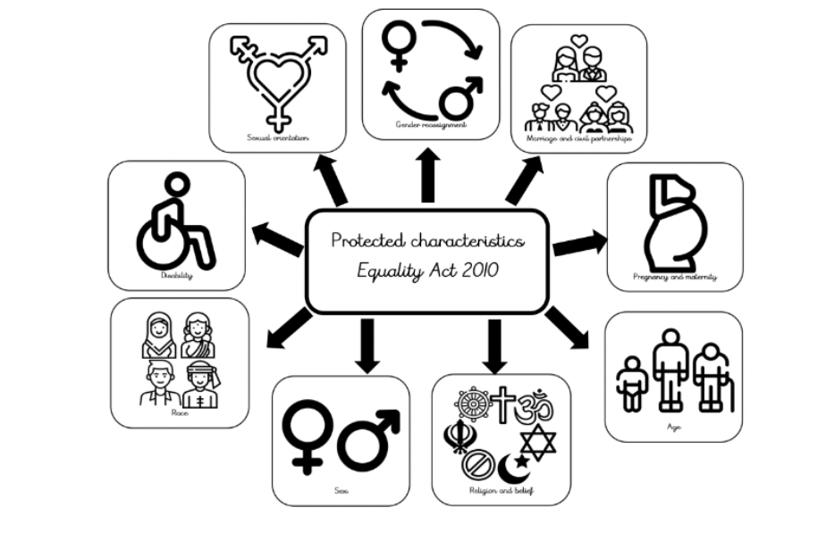

We aim to achieve this through the delivery of an inclusive curriculum and learning environment where all individuals can see themselves reflected within it and which prepares them for life in a diverse society. The nine protected characteristics are promoted through our curriculum deliver and will allow all children at Broadstone Hall to become successful learners, have a strong sense of belonging in line with our behaviour blueprint and become confident and responsible citizens in line with our core values.

Equality Objectives 2022-2023
- Ensure all staff members are familiar with the Equality Act 2010 and their responsibilities within this.
- To foster a culture that empowers children to challenge their misconceptions and build their knowledge of others around them by continually evaluating the curriculum to maximise opportunities to teach and learn about equality.
- To carefully map the nine protected characteristics across our long-term subject plans.
- To continue to recognise and celebrate diversity with our community whilst promoting community cohesion

